**[Title of abstract]**

Author one1,\*, Author two1, Author three2, Author four2

*1**Affiliation one*

*2**Affiliation two*

*\*firstauthor@email.com*

You can insert the text of your abstract in this area. If necessary, you may include a figure and/or a list of references. If you include a figure, it must have its own caption. Both the figure (Figure 1) and the references (e.g. [1], [1,2], [1-3]) should be referenced within the text of the abstract.

It is recommended that the abstract contains a maximum of 1500 characters, including spaces, and the entire submission, inclusive of the figure and references, should fit on a single page.

For formatting, please use the following guidelines: the title should be in 16pt Times New Roman and centered. The author list should be in 12pt Times New Roman and centered. Affiliations should be in italics, in 11pt Times New Roman, aligned to the left. The text of the abstract should be in 12pt Times New Roman and justified. The figure caption should be in 12pt Times New Roman and centered. References should be listed in 11pt Times New Roman, aligned to the left.

Please, submit your abstract file in .pdf format and renamed it with presenter’s Lastname\_Firstname.

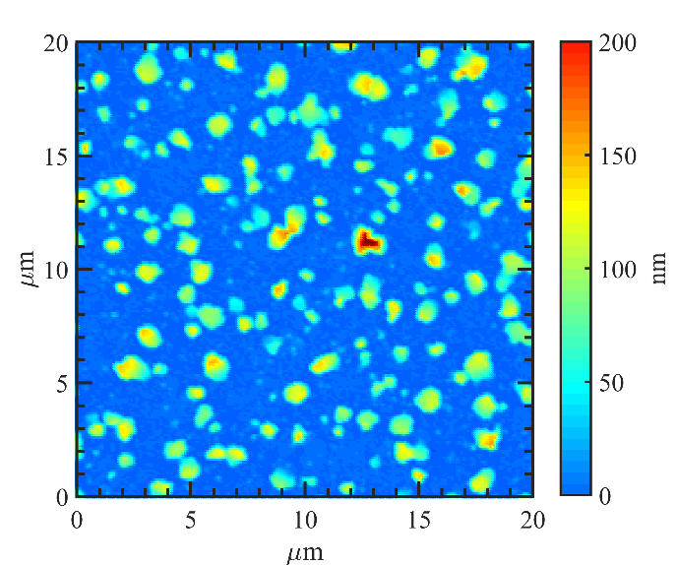C:\Users\pelizzomadmin\Downloads\Sio40_ir_002kx_m06.tif

**Figure 1** Caption of the figure.

**References**

1. Reference one
2. Reference two
3. Reference three